**5.3 Optimizing Two-Class Logistic Regression**

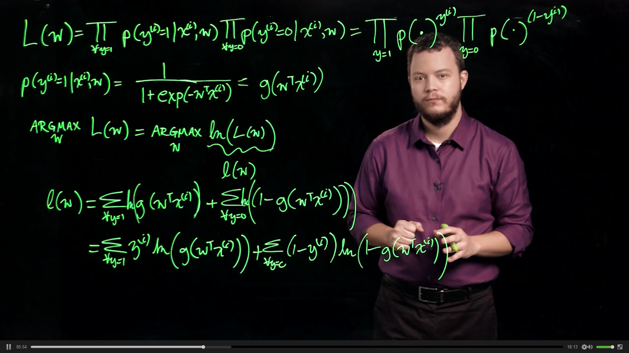

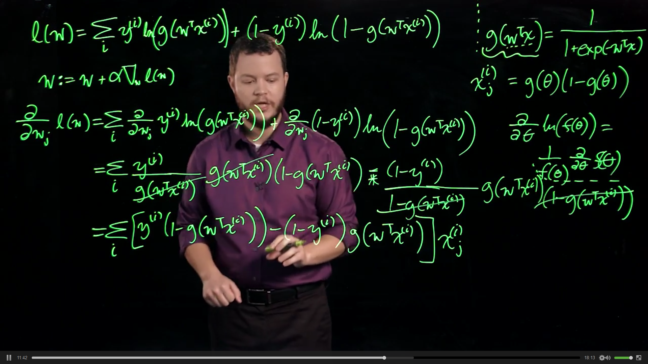

ith instance of x jth attribute

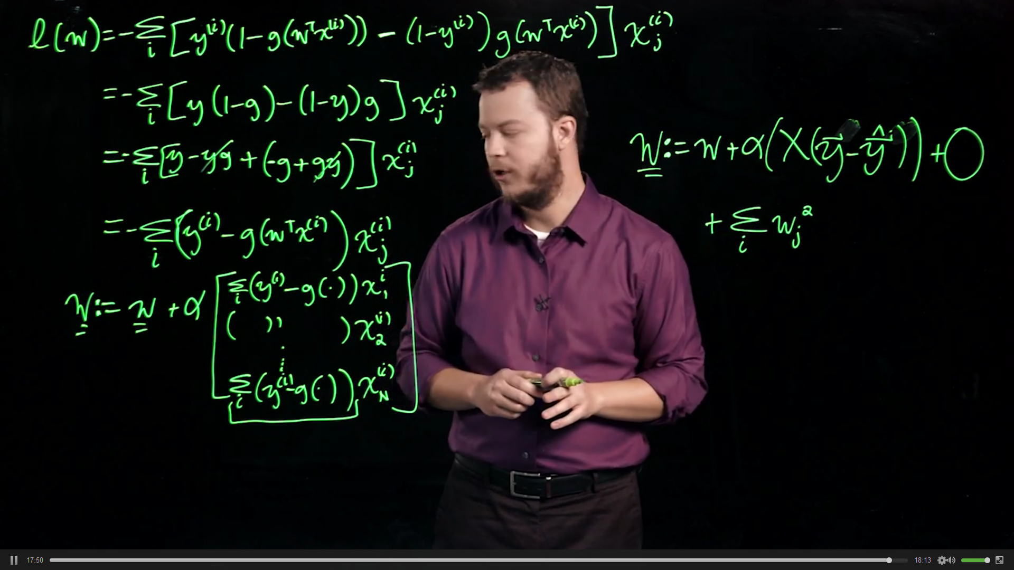

**5.4 Multi-class logistic regression**

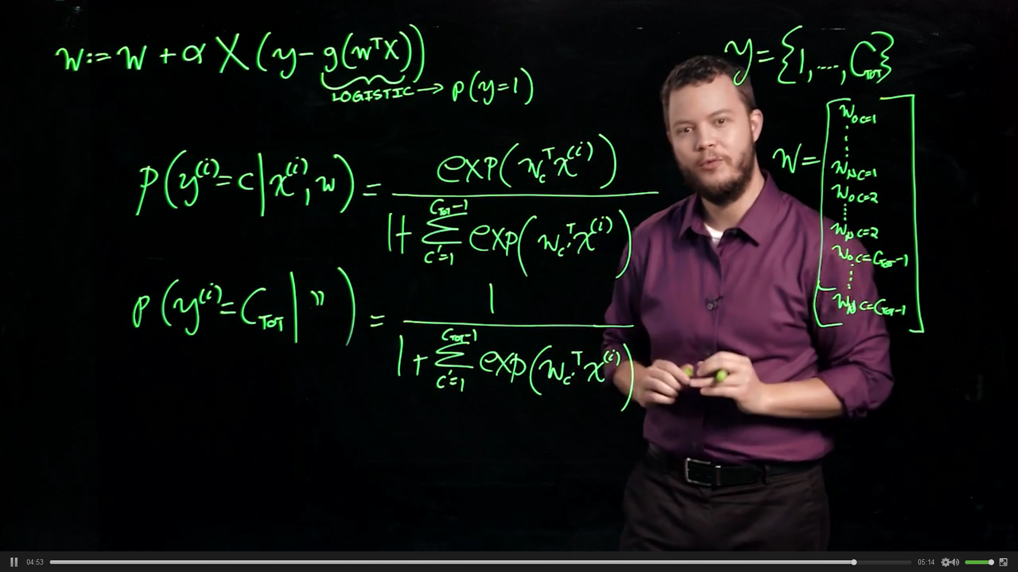

**5.5 Methods of Gradient Optimization: Updates Batch, Stochastic**

Batch gradient descent was what was done before

Stochastic gradient descent, much less computationally intensive

Mini-Batch gradient descent, slightly more optimal than stochastic (on average)

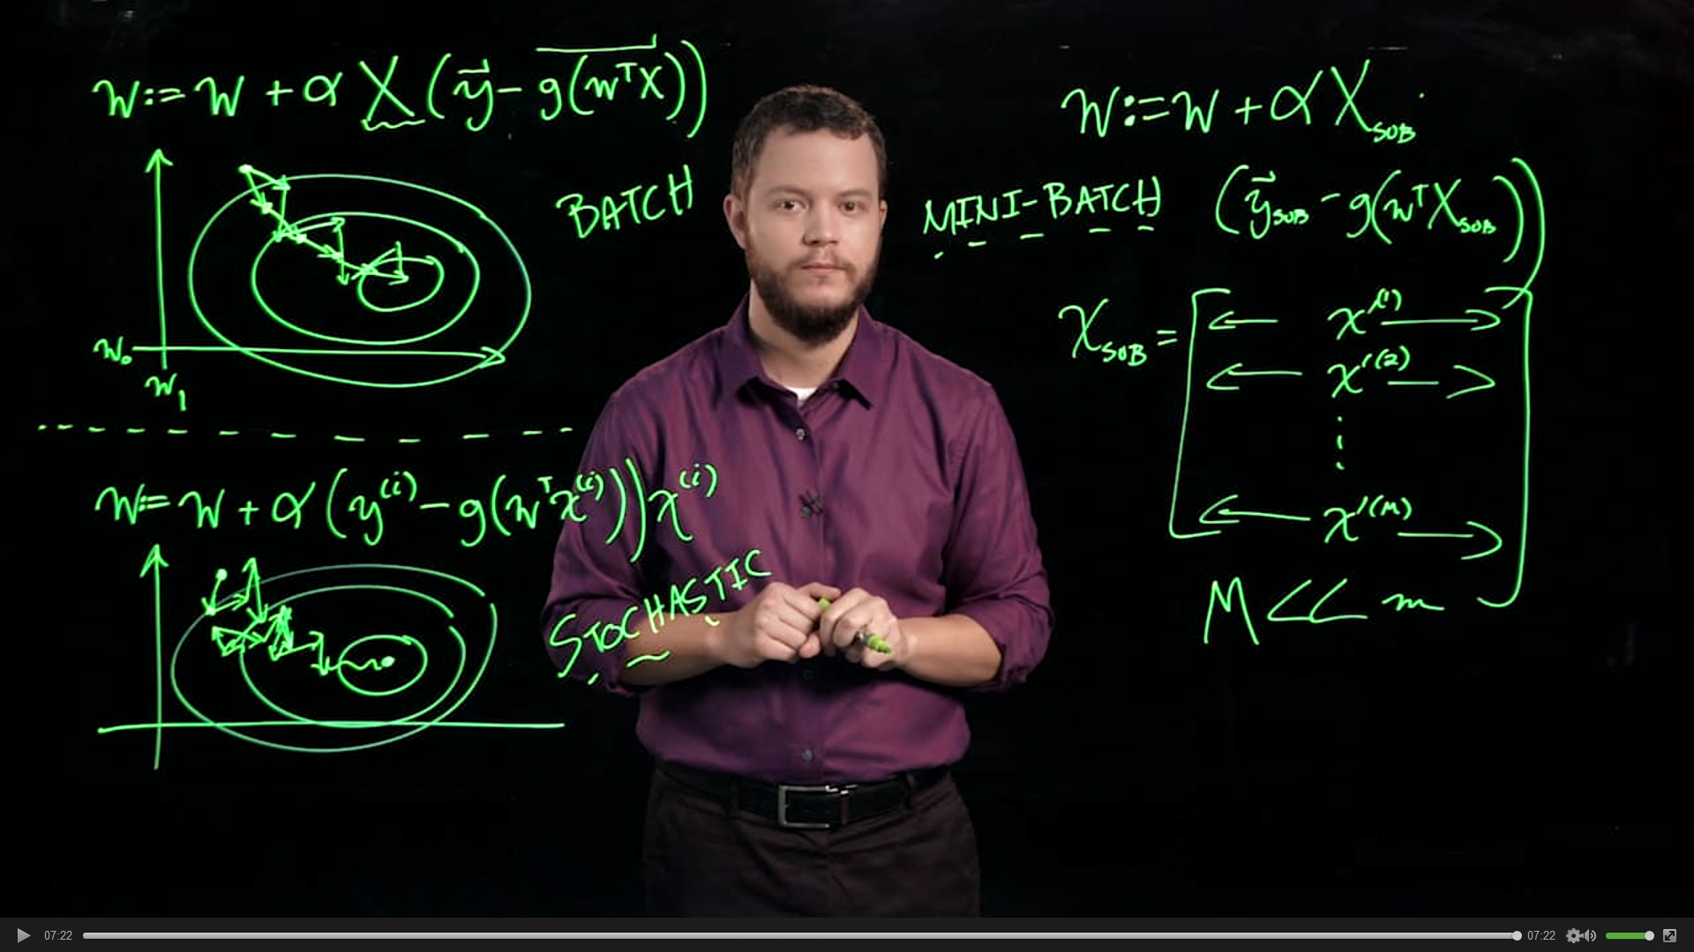

**5.6 Support Vector Machines**

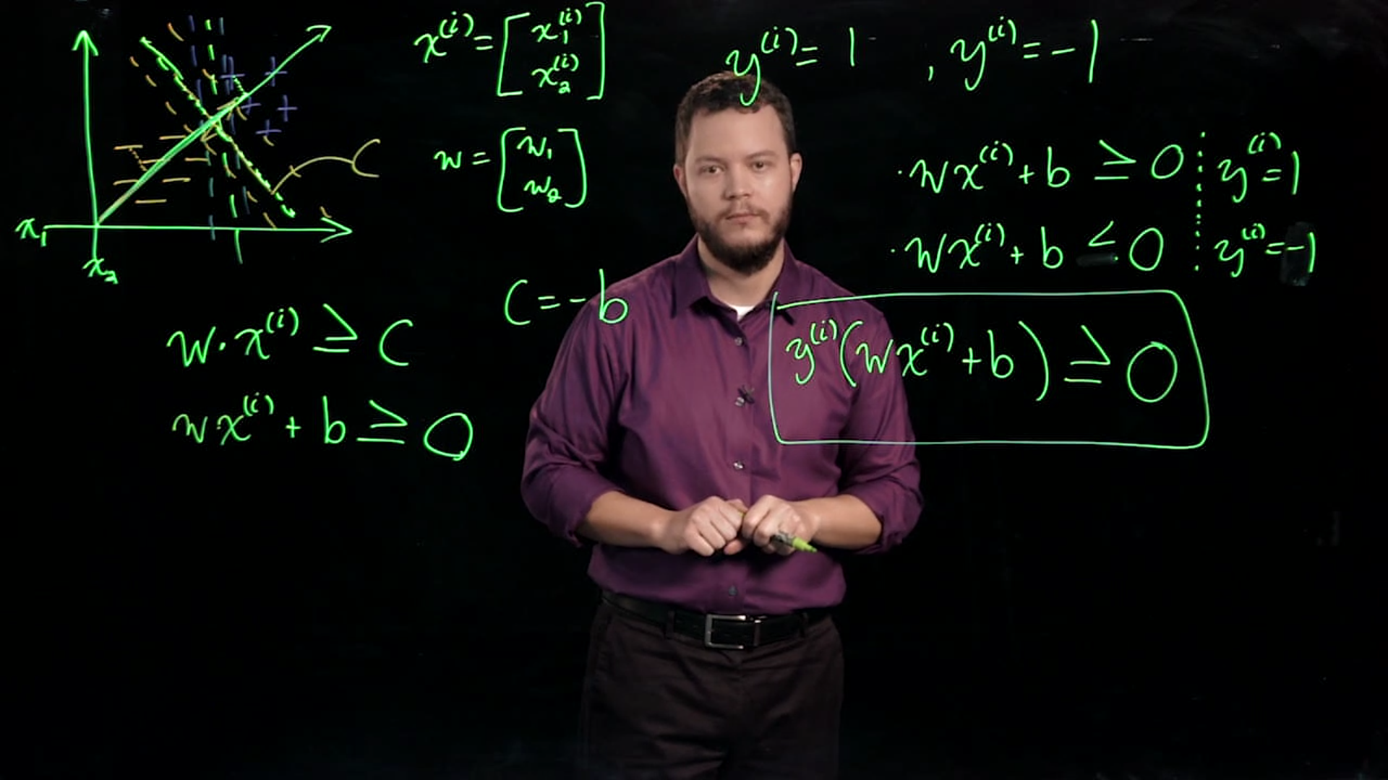

Projecting the vector down to w so that you get a scalar value of the margin

||w|| is the magnitude of vector w

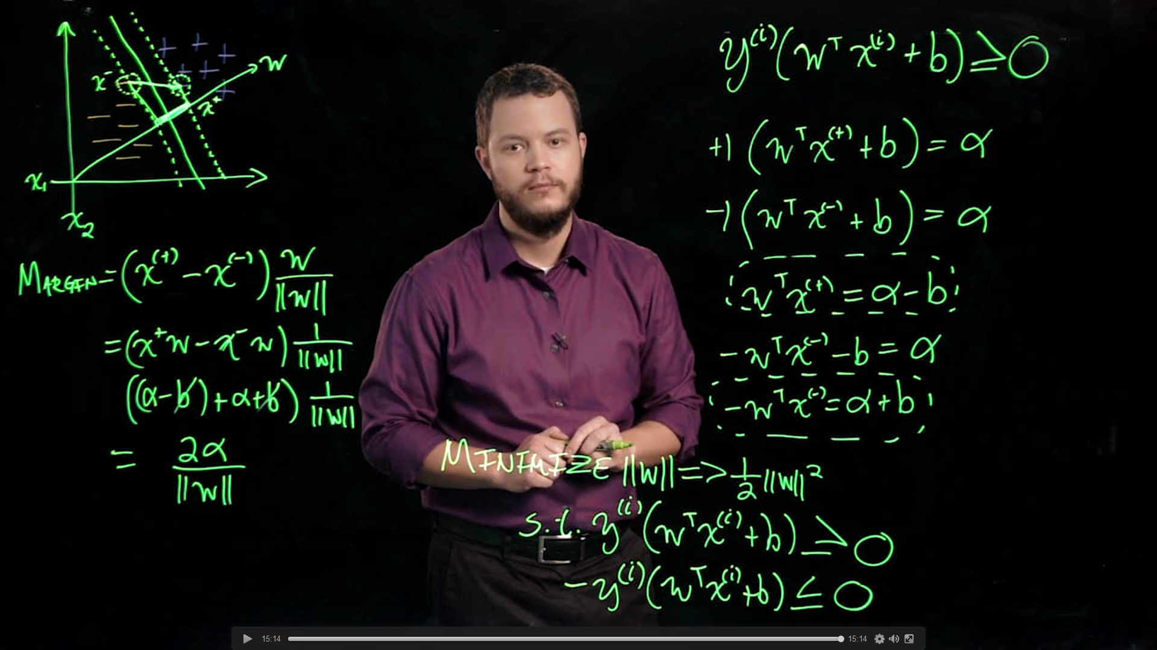

Flipping the max and min is called the (DUAL) instead of (PRIMAL)

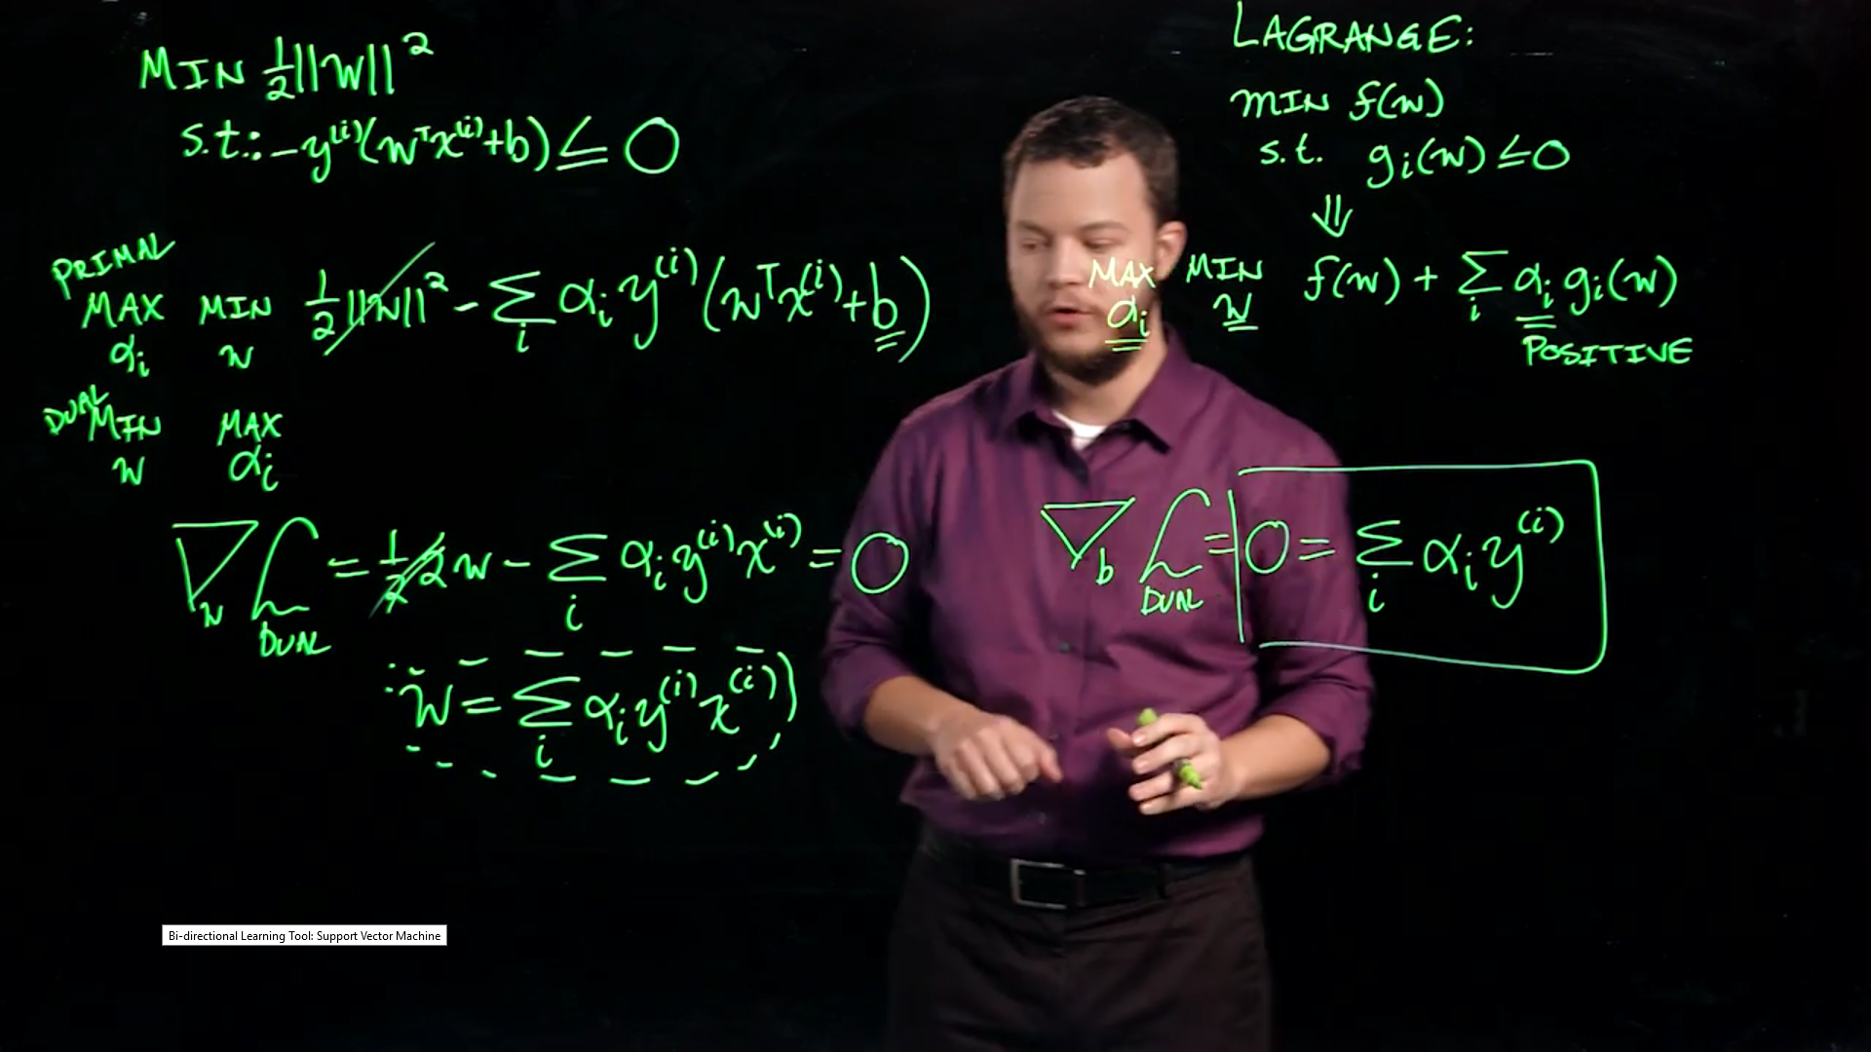

Alphas that are not 0 are the support vectors

The sum of alpha sub i squared is the regularization vector

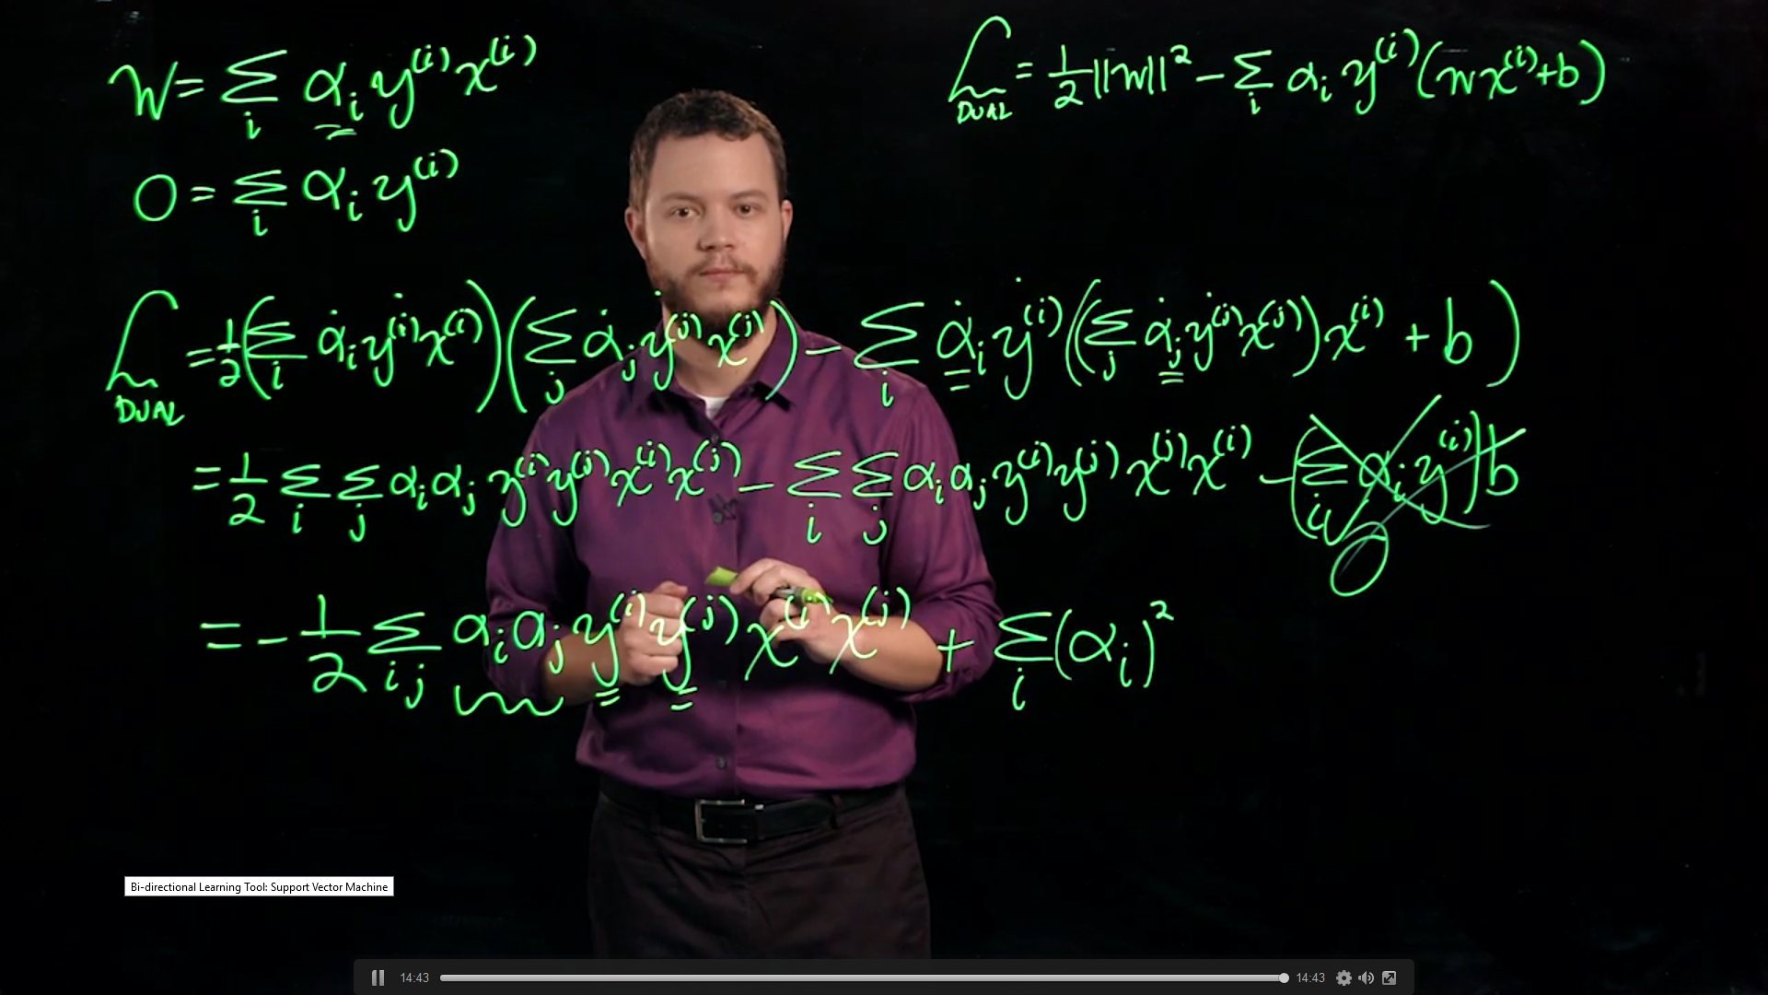

**5.7 Kernel Trick**

‘Slack variables’ something that can point directly at one that is incorrectly predicted. The vector has a value of zeta. Want to minimize the zetas.

Transform it into an extra dimension (kernel trick) so that it can be separated by a plane

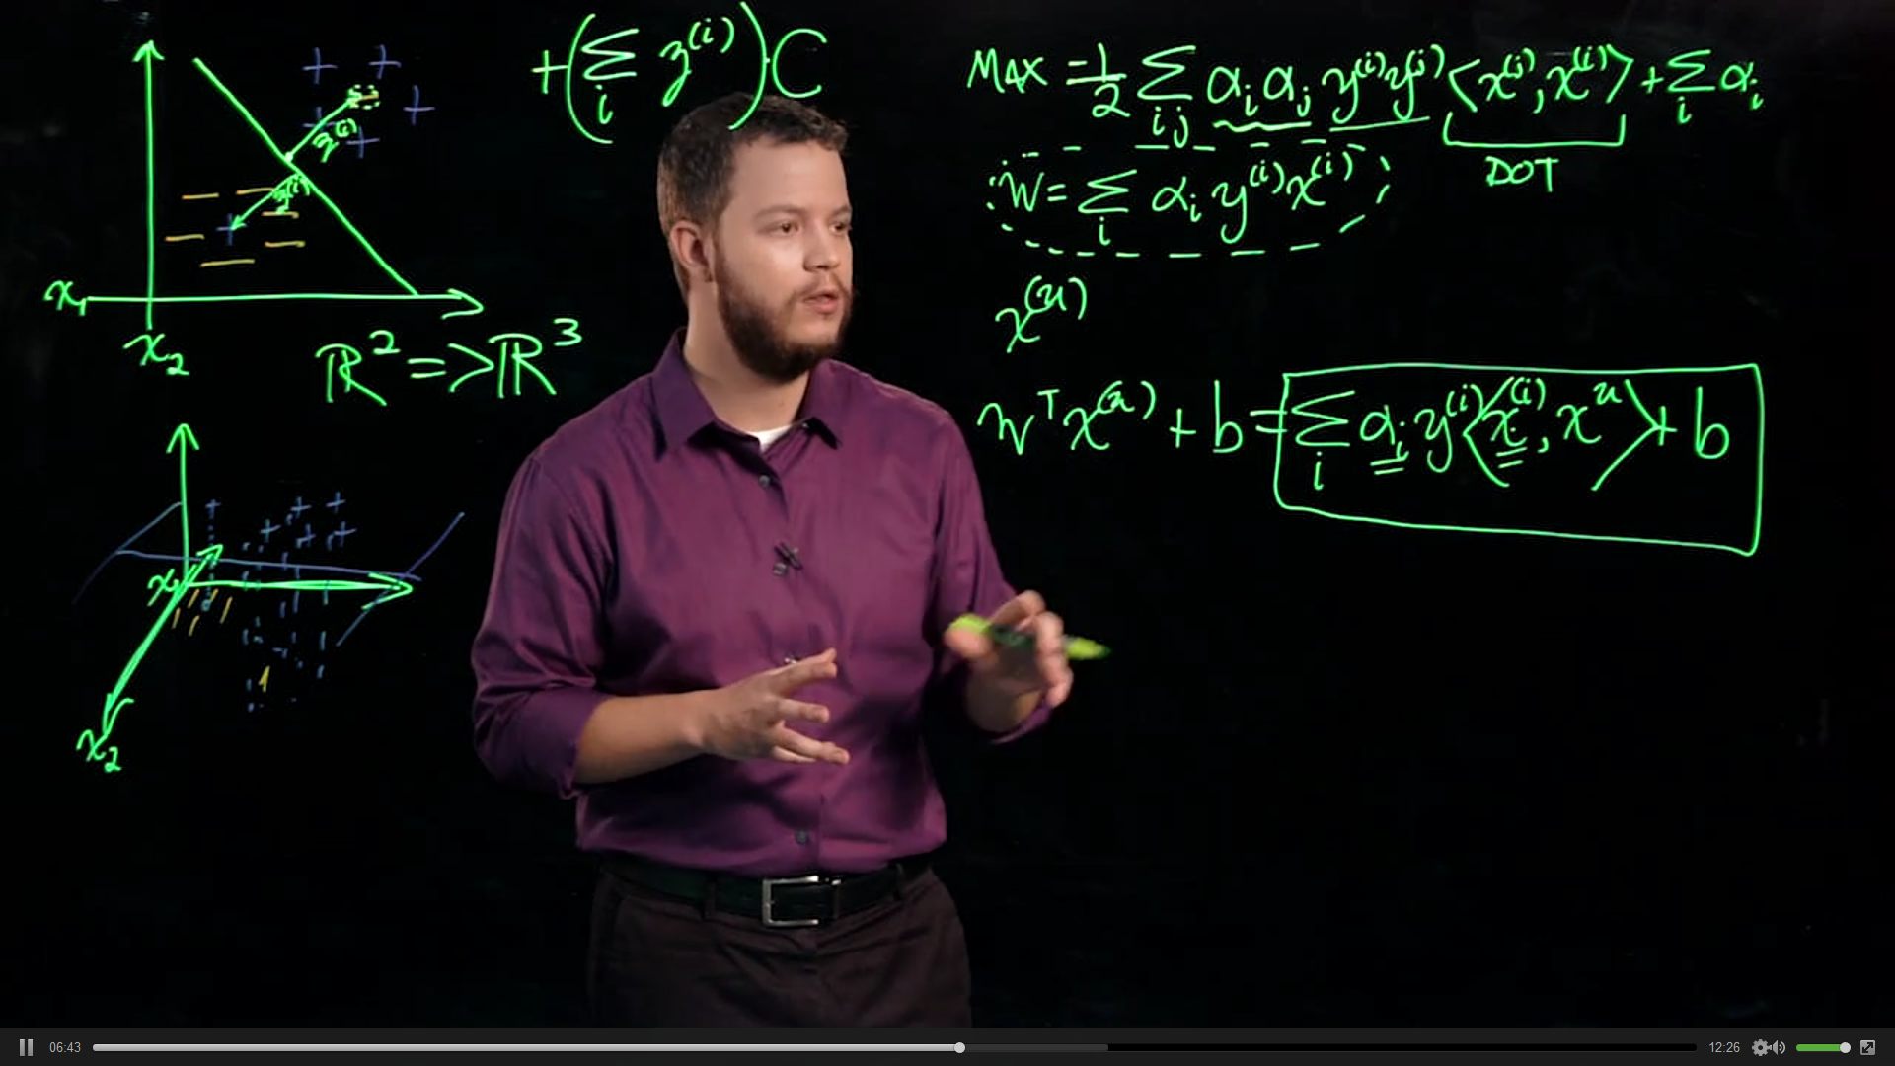

Phi (O with an I through it) is the transformation that maps it to a higher dimension

K is the kernel function

Even things that would have to be represented in infinitely dimension, don’t have to worry about it because it can just simply be represented. And guaranteed that there is a higher dimension where it is linearly seperable.

